

MATHEMATICS
METHODS

Test 5 –Differentiation and Applications of Differentiation
Semester 2 2016

Section Two – Calculator Assumed
Time allowed for this section
Working time for this section: 30 minutes
Marks available: 28 marks
Materials required/recommended for this section
To be provided by the supervisor
This Question/Answer Booklet
Formula Sheet
To be provided by the student
Standard items: pens, pencils, pencil sharpener, eraser, correction fluid/tape, ruler, highlighters
Special items: drawing instruments, templates, notes on one unfolded sheet of A4 paper, and up to three calculators satisfying the conditions set by the Curriculum Council for this examination.
Important note to candidates
No other items may be used in this section of the paper. It is your responsibility to ensure that you do not have any unauthorised notes or other items of a non-personal nature in the room. If you have any unauthorised material with you, hand it to the supervisor before reading any further. All working out must be shown for full marks to be awarded.

- (9 marks)
- On the axes below, sketch the graph of y = x³ – 5x² + 2x – 3 [3]
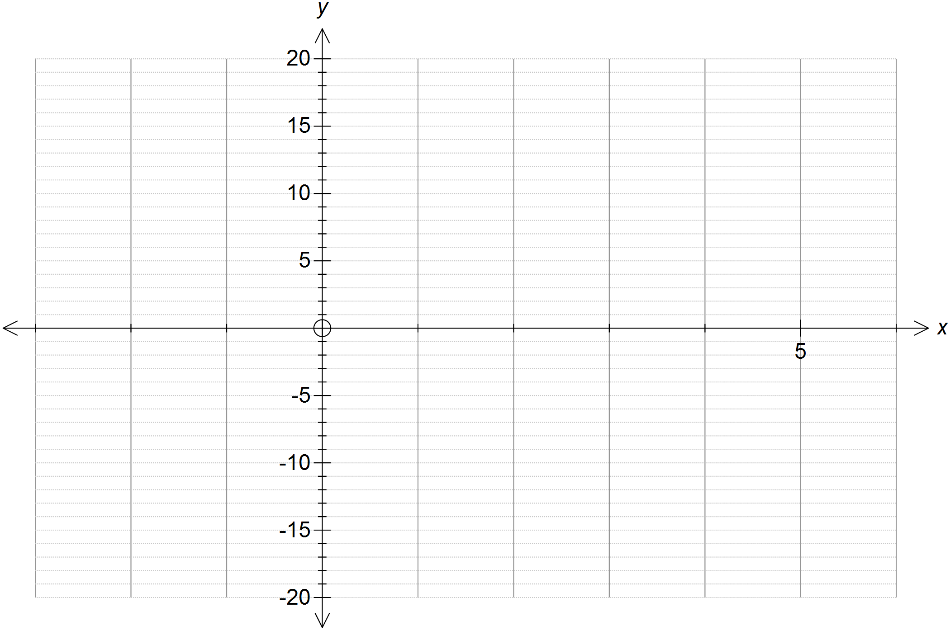
- Show all of the x-intercepts and y-intercepts on the graph above. [2]
- Find [1]

- For what values of x does the tangent to y = x³ – 5x² + 2x – 3 have a negative slope? [1]

- Sketch the tangents to the curve, y = x³ – 5x² + 2x – 3, at the points where x = -1 and
x = 4. [2]

- (3 marks)
Given determine:
- [1]

- [1]

- [1]

- (2 marks)
Determine

- (4 marks)
Determine the derivative of by using first principles.

- (3 marks)
The volume of water flowing through a pipe is given by , where V is the volume in litres and t is the time in minutes. Find the rate of water flow after 7 minutes.

- (3 marks)
A model helicopter is flown so that it its height above the ground is given by at t seconds, where the height is in metres. Find each of the following.
a Its height after 4 seconds. [1]

b Its velocity after 4 seconds. [2]

- (4 marks)
Let be the displacement function of a particle moving in a straight line, where t is in seconds and s is in metres. Find the acceleration when the velocity is 2.

End of Test

